AA2

Match the following.

Column A | Column B
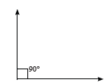 | - Acute angle
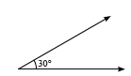 | - Right angle
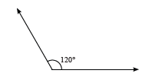 | - Reflex angle
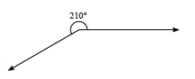 | - Straight angle
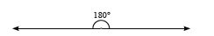 | - Obtuse angle
Answer-
I – b
2 – a
3 – e
4 – c
5 - d

