Spelling activity - Become - Grade 1 - Chapter 1

Rubric: Listen to the audio and look at the picture to identify the word. Fill in the missing letters.
- Ball
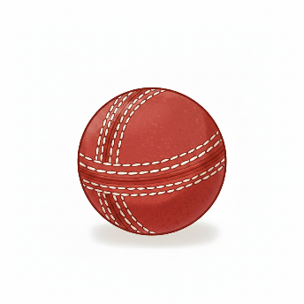
Level 1: bal_
Level 2: ba__
Level 3: _a__
- Bell
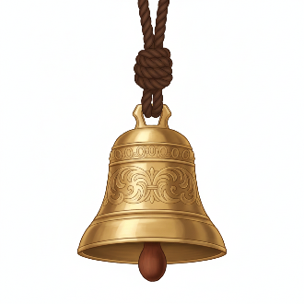
Level 1: bel_
Level 2: ___ll
Level 3: __l_
- Mall

Level 1: mal_
Level 2: m__l
Level 3: m___
- Pill
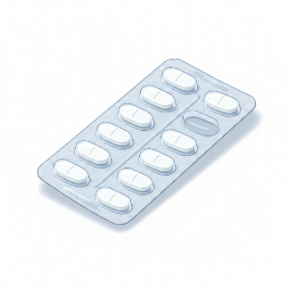
Level 1: pil_
Level 2: _i_l
Level 3: ___l
- Bull

Level 1: bul_
Level 2: _u_l
Level 3: b___

